**Lab1: Write a Pandas program to detect missing values of a given DataFrame.**

**Input:**

**df = pd.DataFrame({ 'ord_no':[70001,np.nan,70002,70004,np.nan,70005,np.nan,70010,70003,70012,np.na n,70013], 'purch_amt':[150.5,270.65,65.26,110.5,948.5,2400.6,5760,1983.43,2480.4,250.45, 75.29,3045.6], 'ord_date': ['2012-10-05','2012-09-10',np.nan,'2012-08-17','2012-09-10','2012-07-27','2012-09-10' ,'2012-10-10','2012-10-10','2012-06-27','2012-08-17','2012-04-25'], 'customer_id':[3002,3001,3001,3003,3002,3001,3001,3004,3003,3002,3001,3001], 'salesman_id':[5002,5003,5001,np.nan,5002,5001,5001,np.nan,5003,5002,5003,np.n an]})**

**Code:**

**import pandas as pd**

**import numpy as np**

**# Input DataFrame**

**df = pd.DataFrame({**

**'ord_no': [70001, np.nan, 70002, 70004, np.nan, 70005, np.nan, 70010, 70003, 70012, np.nan, 70013],**

**'purch_amt': [150.5, 270.65, 65.26, 110.5, 948.5, 2400.6, 5760, 1983.43, 2480.4, 250.45, 75.29, 3045.6],**

**'ord_date': ['2012-10-05', '2012-09-10', np.nan, '2012-08-17', '2012-09-10', '2012-07-27', '2012-09-10',**

**'2012-10-10', '2012-10-10', '2012-06-27', '2012-08-17', '2012-04-25'],**

**'customer_id': [3002, 3001, 3001, 3003, 3002, 3001, 3001, 3004, 3003, 3002, 3001, 3001],**

**'salesman_id': [5002, 5003, 5001, np.nan, 5002, 5001, 5001, np.nan, 5003, 5002, 5003, np.nan]**

**})**

**# Detect missing values**

**missing_values = df.isnull()**

**print("Missing Values Detected:")**

**print(missing_values)**

**Output:**

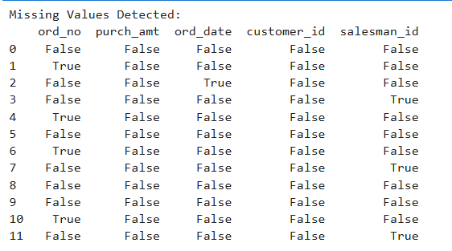

**Lab2: Write a Pandas program to drop the rows where at least one element is missing in a given DataFrame.**

**Input:**

**df = pd.DataFrame({ 'ord_no':[70001,np.nan,70002,70004,np.nan,70005,np.nan,70010,70003,70012,np.na n,70013], 'purch_amt':[150.5,270.65,65.26,110.5,948.5,2400.6,5760,1983.43,2480.4,250.45, 75.29,3045.6], 'ord_date': ['2012-10-05','2012-09-10',np.nan,'2012-08-17','2012-09-10','2012-07-27','2012-09-10' ,'2012-10-10','2012-10-10','2012-06-27','2012-08-17','2012-04-25'], 'customer_id':[3002,3001,3001,3003,3002,3001,3001,3004,3003,3002,3001,3001], 'salesman_id':[5002,5003,5001,np.nan,5002,5001,5001,np.nan,5003,5002,5003,np.n an]})**

**Code:**

**# Drop rows with at least one missing value**

**df = pd.DataFrame({**

**'ord_no': [70001, np.nan, 70002, 70004, np.nan, 70005, np.nan, 70010, 70003, 70012, np.nan, 70013],**

**'purch_amt': [150.5, 270.65, 65.26, 110.5, 948.5, 2400.6, 5760, 1983.43, 2480.4, 250.45, 75.29, 3045.6],**

**'ord_date': ['2012-10-05', '2012-09-10', np.nan, '2012-08-17', '2012-09-10', '2012-07-27', '2012-09-10',**

**'2012-10-10', '2012-10-10', '2012-06-27', '2012-08-17', '2012-04-25'],**

**'customer_id': [3002, 3001, 3001, 3003, 3002, 3001, 3001, 3004, 3003, 3002, 3001, 3001],**

**'salesman_id': [5002, 5003, 5001, np.nan, 5002, 5001, 5001, np.nan, 5003, 5002, 5003, np.nan]**

**})**

**df_cleaned = df.dropna()**

**print("DataFrame After Dropping Rows with Missing Values:")**

**print(df_cleaned)**

**Output:**

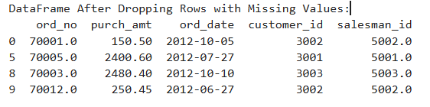

**Lab3: Write a Pandas program to drop the rows where all elements are missing in a given DataFrame.**

**Input:**

**df = pd.DataFrame({ 'ord_no':[np.nan,np.nan,70002,70004,np.nan,70005,np.nan,70010,70003,70012,np.n an,70013], 'purch_amt':[np.nan,270.65,65.26,110.5,948.5,2400.6,5760,1983.43,2480.4,250.45, 75.29,3045.6], 'ord_date': [np.nan,'2012-09-10',np.nan,'2012-08-17','2012-09-10','2012-07-27','2012-09-10','201 2-10-10','2012-10-10','2012-06-27','2012-08-17','2012-04-25'], 'customer_id':[np.nan,3001,3001,3003,3002,3001,3001,3004,3003,3002,3001,3001]})**

**Code:  
# New Input DataFrame for Lab3**

**df = pd.DataFrame({**

**'ord_no': [np.nan, np.nan, 70002, 70004, np.nan, 70005, np.nan, 70010, 70003, 70012, np.nan, 70013],**

**'purch_amt': [np.nan, 270.65, 65.26, 110.5, 948.5, 2400.6, 5760, 1983.43, 2480.4, 250.45, 75.29, 3045.6],**

**'ord_date': [np.nan, '2012-09-10', np.nan, '2012-08-17', '2012-09-10', '2012-07-27', '2012-09-10', '2012-10-10',**

**'2012-10-10', '2012-06-27', '2012-08-17', '2012-04-25'],**

**'customer_id': [np.nan, 3001, 3001, 3003, 3002, 3001, 3001, 3004, 3003, 3002, 3001, 3001]**

**})**

**# Drop rows where all elements are missing**

**df_cleaned_all = df.dropna(how='all')**

**print("DataFrame After Dropping Rows Where All Elements Are Missing:")**

**print(df_cleaned_all)**

**Output:**

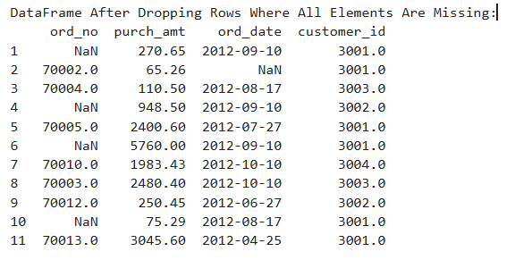

**Lab4: Write a Pandas program to drop those rows from a given DataFrame in which specific columns have missing values.**

**Input:**

**df = pd.DataFrame({ 'ord_no':[np.nan,np.nan,70002,np.nan,np.nan,70005,np.nan,70010,70003,70012,np.n an,np.nan], 'purch_amt':[np.nan,270.65,65.26,np.nan,948.5,2400.6,5760,1983.43,2480.4,250.45, 75.29,np.nan], 'ord_date': [np.nan,'2012-09-10',np.nan,np.nan,'2012-09-10','2012-07-27','2012-09-10','2012-10 10','2012-10-10','2012-06-27','2012-08-17',np.nan], 'customer_id':[np.nan,3001,3001,np.nan,3002,3001,3001,3004,3003,3002,3001,np.na n]})**

**Code:**

**# New Input DataFrame for Lab4**

**df = pd.DataFrame({**

**'ord_no': [np.nan, np.nan, 70002, np.nan, np.nan, 70005, np.nan, 70010, 70003, 70012, np.nan, np.nan],**

**'purch_amt': [np.nan, 270.65, 65.26, np.nan, 948.5, 2400.6, 5760, 1983.43, 2480.4, 250.45, 75.29, np.nan],**

**'ord_date': [np.nan, '2012-09-10', np.nan, np.nan, '2012-09-10', '2012-07-27', '2012-09-10', '2012-10-10',**

**'2012-10-10', '2012-06-27', '2012-08-17', np.nan],**

**'customer_id': [np.nan, 3001, 3001, np.nan, 3002, 3001, 3001, 3004, 3003, 3002, 3001, np.nan]**

**})**

**# Drop rows with missing values in 'ord_no' and 'purch_amt' columns**

**df_cleaned_specific = df.dropna(subset=['ord_no', 'purch_amt'])**

**print("DataFrame After Dropping Rows with Missing Values in Specific Columns:")**

**print(df_cleaned_specific)**

**Output:**

